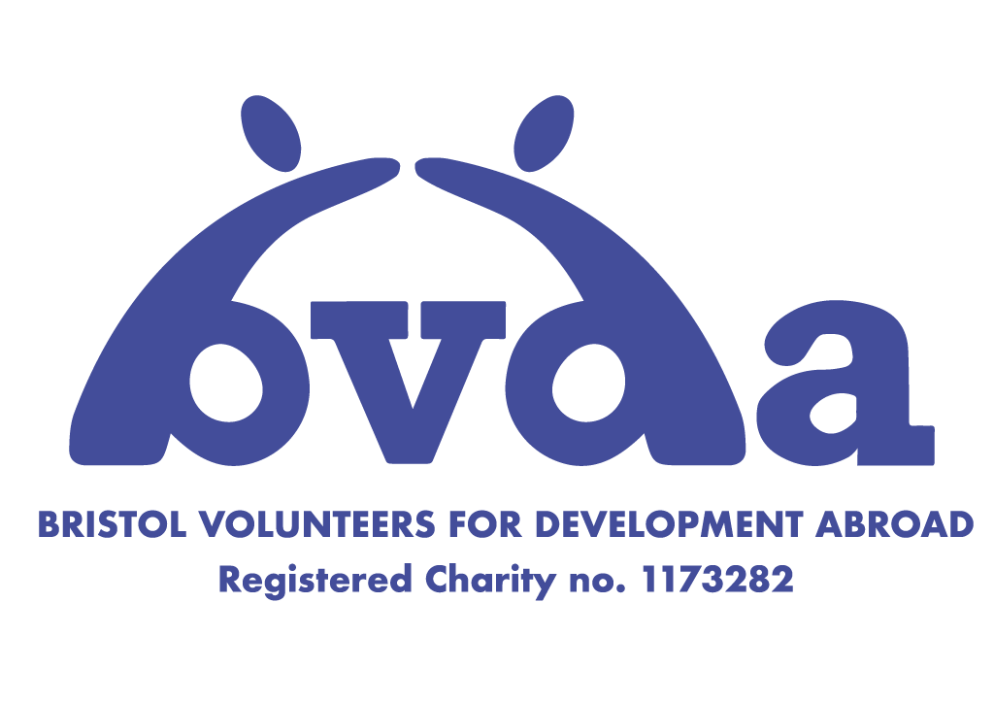

Bristol Volunteers for Development Abroad

Social Project Proposal Form

2021 - 2022

Checklist

Before submission please use the checklist below to ensure you have fulfilled all of our requirements. Attach the budget and time-tables separately.

Main form ⃞

Budget ⃞

Time Table ⃞

Volunteer Time Table ⃞

Photos (If possible) ⃞

Safeguarding Policy ⃞

Data protection ⃞

Host Details

  - Contact details for the main contact: (Who will be the main point of contact with BVDA and the volunteers throughout the year?)

Name:

Position:

Phone:

Email:

Address:

  - If you are an organisation, tell us your aims. (Can be a copy of your mission statement or what your organisation hopes to achieve and why it was first started)

  - What projects have your community or organisation been involved in before?

  - What other Governmental or Non-Governmental projects have been completed or are ongoing in the local area?

  - Has the organisation worked with BVDA before? If yes, please briefly describe the past project and its outcomes.

  - How did the organisation hear about BVDA?

  - What are the organisation's plans for the future?

  - Are you aware of any other organisations also applying for an BVDA project in 2021-22?

  - Does the organisation have a website or any other social media platforms? If yes, please list them.

  - Please list the organisations you are a part of or any partnerships you have with other NGOs/communities or government.

  - Please give details of grants or donations you have received in the past, and if you are still receiving these grants.

  - Please tell us if you have hosted volunteers in the past. Where were they from? In what time period were they there? What were they working on?

PROJECT LOCATION

  - Village/Town/City:

  - Region and Country:

  - What is the population of the community where the project is located?

  - What is the mix of religions in the area? (BVDA does not discriminate on the basis of religious beliefs or gender, nor do we accept projects that do so.)

  - What facilities are there currently in the local area? Please provide details of schools, hospitals, health centres, community centres and all other local amenities. (BVDA would like to get an impression of the infrastructure that currently exists in the community where the project will be situated. Give details including the number of facilities, how many people they cater for and how many minutes walk they are from the project site.)

PROJECT DETAILS

  - What project are you proposing to BVDA for implementation in 2021-22? (Please provide as much detail as possible about what you would hope to achieve during the BVDA volunteers’ time on the project.)

  - How was the project idea developed? (Provide details of how the project idea originated, why it is believed to be necessary, and the different people who have been involved in its development to date.)

  - Does the project require permission from local government or other organisations? If so please provide details and appropriate contact information.

  - To what extent is the success of the project directly reliant on the support of local government figures (e.g. government paid teachers)?

  - Who will be involved in the project alongside the BVDA volunteers? Will there be any professionally trained individuals involved in the project? (e.g. teachers, social workers)

  - For how long will the project last?

  - Are there any plans to develop this project further once BVDA volunteers leave? If yes, who will be responsible for facilitating these and how will they be funded? (Give detailed plans in both a practical and financial sense. Please remember that acceptance of a project by BVDA does not guarantee its automatic continuance the following year)

  - How will the project be maintained after the BVDA volunteers have left? (Will it be financially independent or require further funding from other sources? How do you intend to ensure the project will continue to serve its purpose once BVDA have left?)

  - Who will benefit directly from the project and how were these beneficiaries chosen?

  - What will be the wider benefits of the project in the short and long term? (Short term = during project implementation, Long term = in the future and beyond collaboration with BVDA)

  - What problems could affect the success of the project in the short term (during the project)? How could they be remedied?

  - What problems could affect the success of the project in the long term (after the project)? How could they be remedied?

BVDA VOLUNTEERS

  - How many volunteers will be required to work on the project?

  - How many weeks would the volunteers be required for? (BVDA volunteers are typically students and attend University during the rest of the year, therefore projects cannot be any longer than 10 weeks, and are usually more than 4. Projects must take place in June, July or August 2022. Please take account of the work they would be involved in and the impact that volunteers would have on local resources and the community.)

  - What characteristics are you looking for in BVDA volunteers? (Please remember that our volunteers are unskilled so we cannot commit to sending a certain type of volunteer, but we can certainly consider any preferences in the recruitment process.)

  - Where would the volunteers live for the duration of the project and how far is this from the project location? (BVDA volunteers are students and do not have much money, therefore accommodation ought to be as cheap and basic as possible. Volunteers usually stay within the community, and communities in the past have offered home stays.)

  - What food would be available for the volunteers for the duration of the project?

  - Please describe how volunteers will be able to access the following resources and how far they are from the project site:

    - Water - how will volunteers be able to access clean and safe drinking water? How far are the nearest sources?

    - Health - How far (in time and distance) is the nearest hospital?

    - Transport links - How far (in time and distance) is the nearest major town or city?

    - Financial - How far (in time and distance) is the nearest bank with an ATM and facilities to exchange traveller’s cheques?

    - Security services - Where are the nearest security services e.g. police, nightwatchman?

  - What activities are the volunteers able to get involved in on the project? Please remember that BVDA volunteers are unskilled.

  - Are there any specific safety risks and precautions that we should be aware of?

    - Health (including Covid-19 situation currently)

    - Political situation

    - Personal security

    - Other

  - Are there other activities BVDA volunteers could get involved in, either on project site or in the local community?

PROJECT BUDGET

  - How much will the project proposed for 2021-22 cost? (Provide here an estimated cost of the project proposed for 2021-22, in the local currency and its equivalent in British Pounds Sterling, showing the exchange rate used.

  - If the budget was not fully raised for any reason, could the project be modified to ensure its completion (please detail exactly how you would do this, and to what extent this would lower the project cost)?

  - What would be the probable living costs for volunteers during the project? Accommodation should be basic and the costs as low as possible.

    - Volunteer accommodation

    - Volunteer food

    - Other expenses associated with the project

SAFEGUARDING

  - Does your organisation have a safeguarding policy for adults and children? Please attach a copy of the policy.

  - Who is your named safeguarding lead? Please provide name and contact details.

  - How does your organisation process incident reports?

DATA PROTECTION

  - Where will you store our volunteers personal data? Is this system password protected?
  - How long will you keep the data on your system?
  - What will you use this information for?

Please sign to state that your organization will follow the following principles of data protection

Signature
I will keep all personal data in a secure place
I will delete personal data when it is no longer required or when asked to by the individual
I will not share any information or data with any other organisations/individuals
I will only use the information or data for relevant purposes
I will only keep information or data that is relevant and necessary

PROJECT HOST DECLARATION

I submit the following application for consideration by Bristol Volunteers for Development Abroad (BVDA). I guarantee that all the information I have provided is correct to the best of my knowledge, and I agree to keep BVDA informed of any changes that affect the information given on this form.

I understand fully the commitment involved in being an BVDA Project Host and that it is my responsibility, if this project is accepted, to both facilitate contact and ensure involvement is maintained on behalf of the host community.

To be completed by the project host applicant:

Name: Date:

Signature:

To be co-signed by appropriate representative:

Name: Date:

Position: Signature:

If you are submitting this form by email then simply identify the project host applicant and appropriate representative – a signature can be obtained at a later date.

